Ultrasonic Sensor Block
ECE44x Wearable Sensor for The Blind Group 34

Keywords—Ultrasonic sensor; water proof; range finder; block description; design verification

Introduction
The purpose of this document is to describe how the ultrasonic sensor being used on the project, to insure that the ultrasonic sensor can be used without any further testing and work as intended. The Ultrasonic sensor will have four pin, which is two for power, 1 for the transmit toggle, and one for the return transmit data toggle. This document will be used to overview of all the function, properties, schematic, and verification of the design, so that the future use of the sensor can be simplyfy.

Block Overview
The Ultrasonic sensor, which will be called module, is a module that transmit and receive sound to detect the distance. .The pwr_spply_ultrsnc_snsr_dcpwr is a power supply to make the module works; it works on 5 DC volts, with 5 mA nominal current. The cntrllr_cd_ultrsnc_snsr_data receive a toggle input from the microcontroller as a string of data in which indicated of what the modul should do, then the module will create a eight pulse signal in which will be transmitted to outer world, then the otsd_ultrsnc_snsr_envin will detect if there is an object within the intended area or not with echo. The echo will toggle off the stream time dealy data that was put when the trigger once set up after a couple microsecond delays, by passing the ultrsnc_snsr_cntrllr_cd_data, the longer the delay to stop the longer it assume the distance. The block diagram of the module system can be seeno on figure 1.

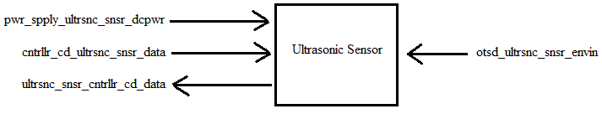
- Black Box Diagram of Ultrasonic Sensor Block
- Display Block Interfaces and Properties
Interface | Properties
otsd_ultrsnc_snsr_envin | 1. Probe Freq.: 40 KHz  2. Range: 20 cm - 500cm  3. Range accuracy : 10cm  4. Angle: 75 degree
pwr_spply_ultrsnc_snsr_dcpwr | 1.Min Voltage: 3 V  2.Max Voltage: 5.5 V  3.Nominal Current: 5mA  4.Peak Current: 30mA
cntrllr_cd_ultrsnc_snsr_data | 1. Pulse Protocol :TTL  2. Pulse Width : 10 us  3. Pulse Voltage: 5 V  4. Messages: Trigger Measurement: 0x55 (1010 1010b)
ultrsnc_snsr_cntrllr_cd_data | 1. Echo Protocol: TTL  2. Echo Width :150 us~25ms (38ms no obstacle)  3. Echo Voltage: 5 V  4. Echo Level During Measurement: 1

Verification
Based on the interfaces for this block, a verification (testing) process needs to be indicated. This will allow for the final constructed design to be tested verifying that all of the interface properties have been met and that the block is ready for integration into the system

Range finder Testing
Link to Video

Power Testing
Link to Video

Reciving Testing
Link to Video

Transmiting Testing
Link to Video
The block will be categorized as pass, when all the testing was pass.

Design
The Wiring Diagram (Fig. 2) presents the block design, including the interfaces of the block. These interfaces are further elaborated through validation information given in Table 2, which demonstrates externaly-supported validy for each of the block’s properties. While the Pulse diagram (Fig.3), is to demonstrated how the ultrasonic module pulse works.

Wiring Diagram
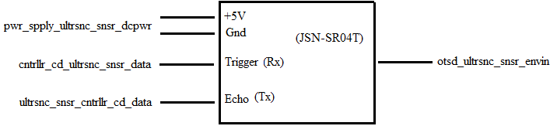
- Wiring Diagram for the Ultrasonic Module Block

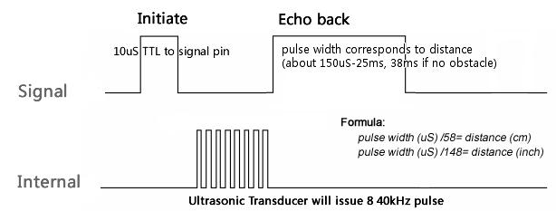
- Pulse Diagram for the Ultrasonic Module Block

Design Validation
- Interface Property Validation for the ultrasonic sensor Block
Property | Validation

- List of bills of materials used for the ultrasonic sensor Block
Property | Validation

REFERENCES

- Adruino, “JSN-SR04T 20-60 0cm ultrasonic waterproof Range Finder ” JSN-SR04T Datasheet, https://drive.google.com/a/oregonstate.edu/file/d/1mWfcWH5f5-8lk2r7KeLZ4dzk0CqiVCk0/view?usp=sharing
- Electrosome, “Interfacing HC-SR04 Ultrasonic sensor with PIC Microcontroller,” https://electrosome.com/hc-sr04-ultrasonic-sensor-pic/, accessed: 12/2/2017

